Name: Emily Chiu

Assignment 3

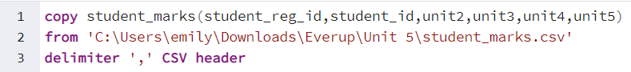

Sample questions:

-- students with the highest marks in Unit 4

-- students scored between 89 and 100 unit4

Open ended questions:

-- Take a closer look at the tables that you created and come up with 10 different scenarios/ questions and form SQL

1. From student_marks, delete the id column

2. From student_marks, format unit 2 from highest to lowest

3. Only show students who got score of 100 in unit 5

4. Only show students whose scores are over 95 in all units

5. Find the mean unit 2 score of the first 10 students.

6. Show students who scored between 90-93 on unit 3

7. From student, format names in alphabetical order

8. Show only female students

9. Show students with a google email

10. Show students whose phone number has ‘232’ as the first 3 numbers or 4th-6th numbers

